An American Sign Language Finger-Spelling Translator
Ryan Patterson
University of Colorado
Electrical and Computer Engineering Freshman
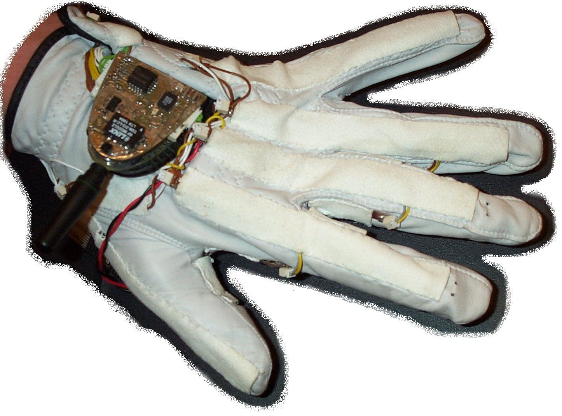
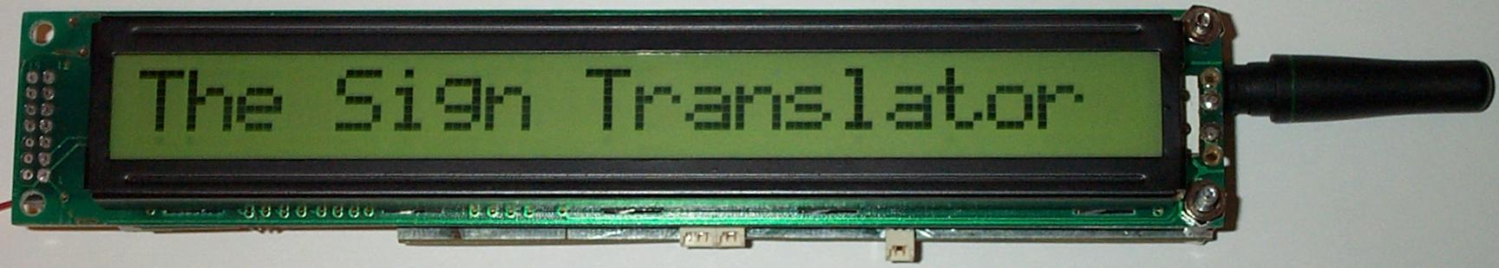
RF Signal to PC
Abstract
Many people in the world are unable to speak because of a profound long-term hearing loss due to disease or injury. People with such permanent hearing losses often use sign language to communicate with each other, but it is very difficult to converse with someone who doesn’t know sign language unless a trained translator is present. If people with hearing losses had a personal device that could readily translate sign language to written English, this communication process would be much easier.

The goal of the project was to explore the design a device which enables translation of the American Sign Language alphabet with a personal electronic device. A modified golf glove was designed to detect hand signals. As the user signs, individual finger and hand positions are sensed and translated into English text using a mathematical comparative analysis program written in Assembly Language and executed on a custom designed microprocessor circuit board. As the user spells a message, the translated letters are wirelessly transmitted to a custom designed real-time electronic display.

Once the device was finished, it was taught the American Sign Language alphabet. The alphabet was then exercised while wearing the device to test its interpretation accuracy. This test proved the device was a successful sign language translator.
RF Signal to Display Module
Downloading Interface Cable
Operation
When a new user begins operation of the translator device, they must first “train” it. This is done by software running on a PC or laptop. The user creates hand signs as they normally would, and the PC records the person’s movements. Once training is completed, the database of trained symbols is downloaded from the PC to the portable display device through a physical cable. The system is now ready to be used in a stand-alone mode, and only the human interface device (glove) and display are needed for full translation abilities.

Features
Many goals were set during design to make the ASL Finger-Spelling Translation System as friendly as possible for the user:
- High translation precision (> 95%)
- Rugged glove design
- Long battery life
- Low cost to OEM user
PC: used temporarily for system training

